Network Design Proposal Template
Network Design Proposal

Prepared for:
University of Maryland University College

Prepared by:
Derand Lee

I. Physical Network Design
Introduction

I am proposing a network design to enhance the student and faculty ability to perform academically and professionally. Students will be able to access the web and email from provided lab computers and onsite library. Faculty will be able to conduct their daily administrative duties as well as instructors being able to interact with students via computers. Security messages will be applied to the network design to ensure safety and privacy for students, faculty and the university as a whole.

A. Network Topology

Business Needs

The University of Maryland University College sets the standard for education. One primary source of educating is via computers. UMUC is committed to providing its staff, faculty and students with the adequate computing resources. The university wants to invest in wisely and appropriately in their staff and student’s needs. The administrative staff (11 personnel) needs to be able to rely on computers to provide fast internet service on a separate network talking to one another. Being that the administrative office handles private personal information, security is a priority. For the students, six labs housing twenty-five computers will need to reside on a network that will include an instructor station in each to communicate with students. Students will also need access to the library resources. A network must be established for the library which house twenty computers for the general public and five computers for the library staff. Lastly two servers will be utilized within the networks. The design will be for a two-story building measuring 240ft x 95ft totaling 45,600 square ft.

Proposed Topology

The star topology will be best suited for establishing a network that will provide services to the multiple labs, offices and library. In a star topology, all computers are connected through one central device known as a hub or a switch. Each workstation has a cable that goes from the network card to the hub device. Example is figure 1. One of the major benefits of a star topology is that a break in the cable causes only the workstation that is connected to the cable to go down, not the entire network [1]. In the event UMUC needed to an addition lab or office with computers, the star topology also allows expanding the network easier. A wired LAN will be configured utilizing Cat6 cabling. Additionally, a wireless network will be established. Each workstation will be configured and fitted with wireless adaptor NICs for wireless internet capabilities. Both wireless and wired networks will use star topology. Table 1 below will summarize what equipment and gear is needed to complete my proposed network. It also provides model type, features, cost and quantity.
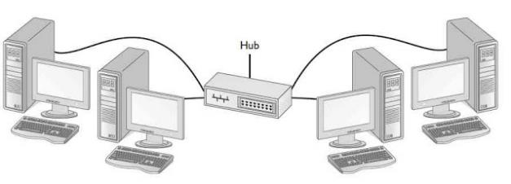
Figure 1: Star Topology example

MODEL TYPE | MANUFACTURER NAME | FEATURES | COST PER | TOTAL
CISCO891-K9 / Router | CISCO | Metro Ethernet, wireless LAN connectivity, integrated V.92 analog modem interface. 2 WAN Ports, 8 LAN ports 10/100/1000, | $648 x 2 | $1296.00
R7800-100NAS Nighthawk / Wireless Router | NETGEAR | IEEE 802.11 b/g/n 2.4 GHz 256 QAM support  IEEE 802.11 a/n/ac 5.0 GHz; WPA / WPA2—PSK; 1 x 10/100/1000M LAN port; 4 x 10/100/1000M LAN ports; 2 USB 3.0 ports;  1 eSATA port; Wireless Data Rates Up to 2.6 Gbps | $198.99 x 6 | $1193.94
WS-C2960-48TC-L  / Switch | CISCO | Layer 2 - 48 x 10/100 Ports - 2 x T/SFP - LAN Base Image – Managed; 2 dual-purpose uplinks 10/100/1000; 16 Gigabit Ethernet (SFP) | $912 x 5 | $4560.00
ASA5505-50-BUN-K9 / Firewall | CISCO | 50 Users, 8 port 10/100 switch with 2 Power over Ethernet ports, 3DES/AES, throughput 150 mbps | $474.00 x5 | $2370.00
TL-WN851ND / Wireless PCI Adaptor | TP-Link | IEEE 802.11b/g/n; Up to 300Mbps; WEP, WPA/WPA2, WPA-PSK/WPA2-PSK; 2.4ghz band; | $19.66 x 186 | $3656.76
13X6-061NH 1000FT | CABLE WHOLESALE | 10 gig Solid, UTP (Unshielded Twisted Pair), 500Mhz, 23 AWG, Spool, 1000 foot | $$213.06 x 5 | $1065.30
106190  100 Pack | PLATINUM TOOLS | These Platinum Tools RJ45 Cat6A 10 Gig Shielded Crimp Connectors are designed for those looking for more bandwidth, therefore needing bigger cables, such as CAT6 and CAT6A. | $101.51 x 5 | $507.55
462-0993 PowerEdge T20 [Xeon] / Server (lab) | DELL | 4GB Memory, 1TB HDD; Quad-core Processor Max Freq 3.6 GHz; 12 USB (four USB 3.0) ports | $610.83 x 6 | $3664.98
R710 2U PowerEdge Rack Server (Server Rooms) | DELL | 2U Rackmount server w/ 6x 3.5" hot-swap backplane; (2) X5660 2.80GHz six core Intel Xeon processors; 96GB RAM; (4) 3TB 7.2k SATA 3.5″ HDD in RAID 5; (4) Gigabit ethernet ports | $1299.00 x 2 | $2598.00
SRW 12.900 / Rack Enclosure | SYSRACKS | Enclosed; Cooling Fan; Fully Lockable Vented shelf; LED-Light Bar;  6-way PDU; Glass Front Door | $369.00 x 2 | $738.00
 |  |  | Total Cost | $21,641.53

Table 1: Equipment summary

Justification

This network installation is for the two story UMUC building with six labs of 25 workstations, six office with 6 workstations, an administration office with 5 workstations, and one server each on first and second floor. To complete the request, 7 Severs, 2 Routers, 6 wireless routers, 5 switches, 5 firewalls, 186 wireless adaptors, 5 Cat6a cable rolls (1000ft), and 5 Cat6a cable plugs (100 count) are required. The cost for equipment is $21,641.53.
To continue to provide the best education and provide staff with the proper resources and work environment, UMUC will benefit with the star topology. One advantage of using the Internet in University education is its ability to allow you to communicate quickly to large numbers of people if necessary. Email allows students and teachers to contact one another even if they cannot physically meet. It enables educators to send out announcements, such as assignments or a course syllabus, without having to hand out paper copies. Students can submit assignments via email or some other online submission system, which can cut down on the amount of paper waste produced by the institution [2]. It will use wireless (IEEE 802.11 b/g/n 2.4 GHz and IEEE 802.11 a/n/ac) and wired LAN configurations (CAT6a). This set-up allows for expansion and upgrades for future requirements. Additionally, this network utilizing CAT6a cables will allow for adaptation with future technology to come.

B. Network Media

Business Needs

UMUC provides higher education. It utilizes computer networking and the internet heavily to educate and to operate the university. Uninterrupted daily academic and administrative activity is a must to succeed. Sustained network and internet connection providing ample speed, minimum maintenance and cost effectiveness is the goal.

The network media will be comprised of Cat6a Ethernet for the LAN network backbone, and 802.11 b/g/n 2.4 GHz and 802.11 a/n/ac for the wireless network. The wireless network signal will cover all UMUC spaces within the building.
Justification

Being that this is a new install, CAT6a is the best option to go with. It is more cost effective than fiber optics and it has the speed capability to meet the future. Planning is important. A few years from now data speeds/bandwidth will increase and the CAT6a cables will be able to support. The wireless network and equipment utilizing 802.11 b/g/n 2.4 GHz and 802.11 a/n/ac will be able to connect all devices due to backwards compatibility. The speed/bandwidth will allow for multiple task of email, school portals, social media and personal device usage.

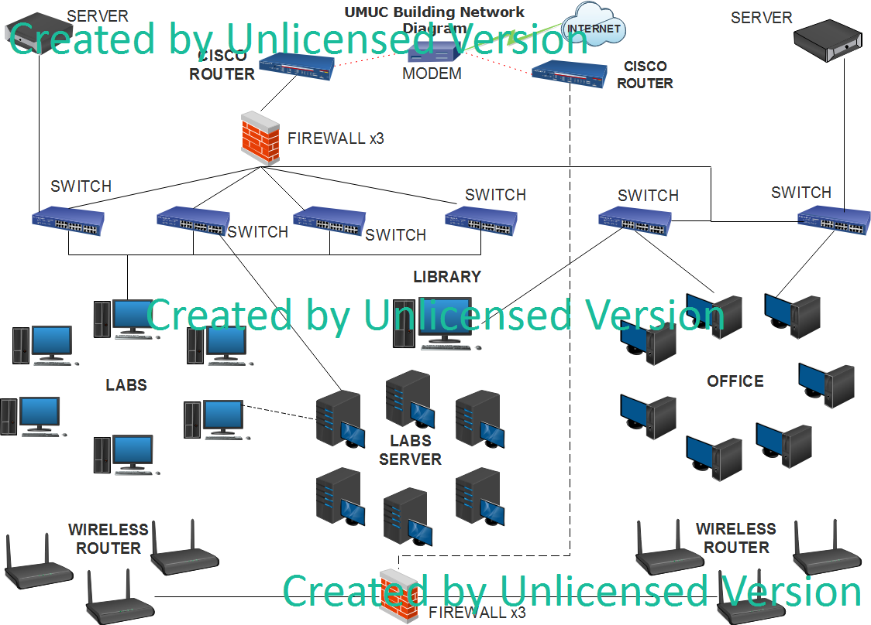

Figure 2. Network Diagram

C. Network Devices

Business Needs

Sharing amongst students and instructors is of high importance. UMUC faculty and administrators will require access to such network services as email, files sharing, and internet access. To keep up with ever changing technology advances, equipment that have future capabilities are necessary when beginning a new network. Technologies that connect, digitise, analyse, automate and simplify are on the rise and they will continue to transform the way we work, learn and live. Where it’s taking us nobody really knows but, in my view, the more we open our minds to what’s possible – and desirable – the more we can steer those unintended consequences to bring more macro-level benefit than disadvantage [3].

Proposed Network Devices

All the network devices and associated gear are listed in Table 1. Below in Figure 3 identify the location of all the network equipment.

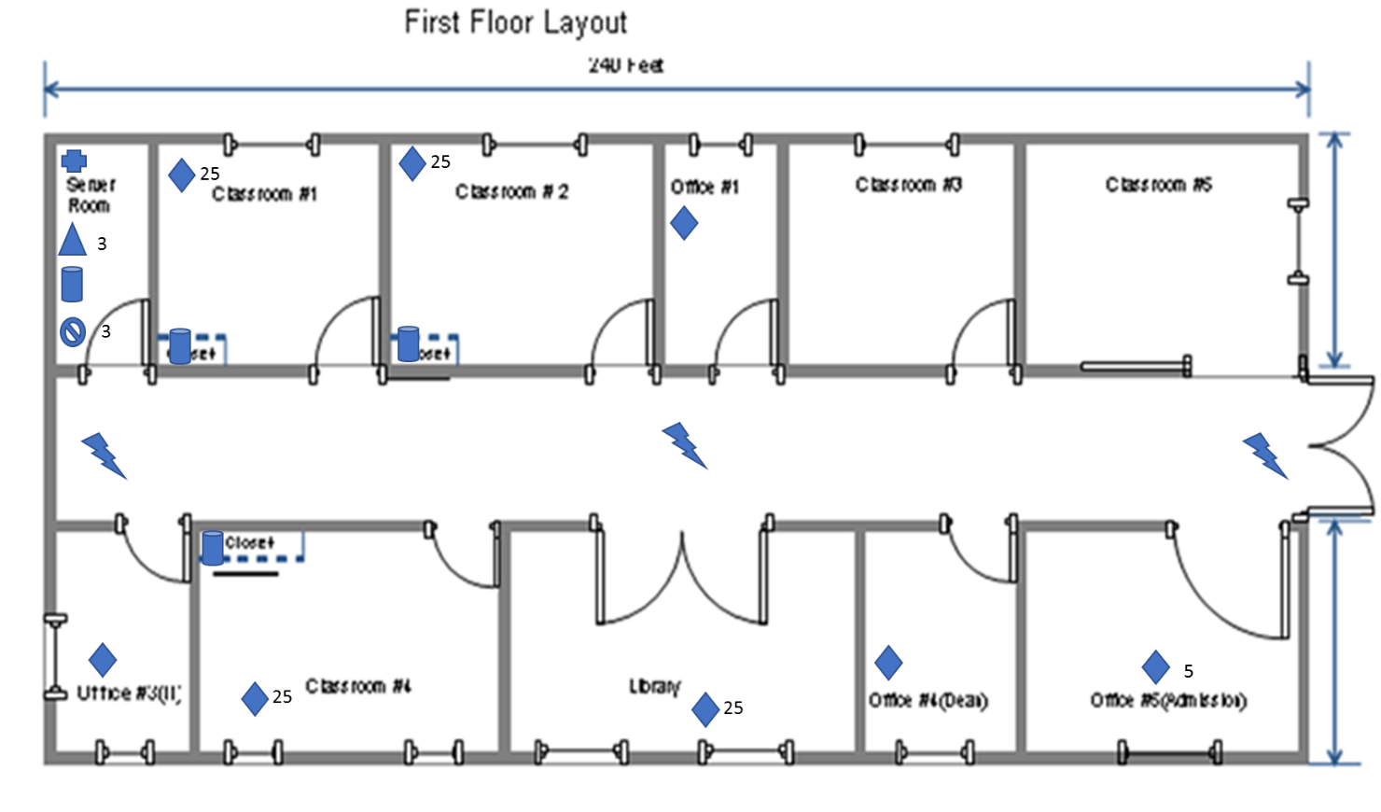

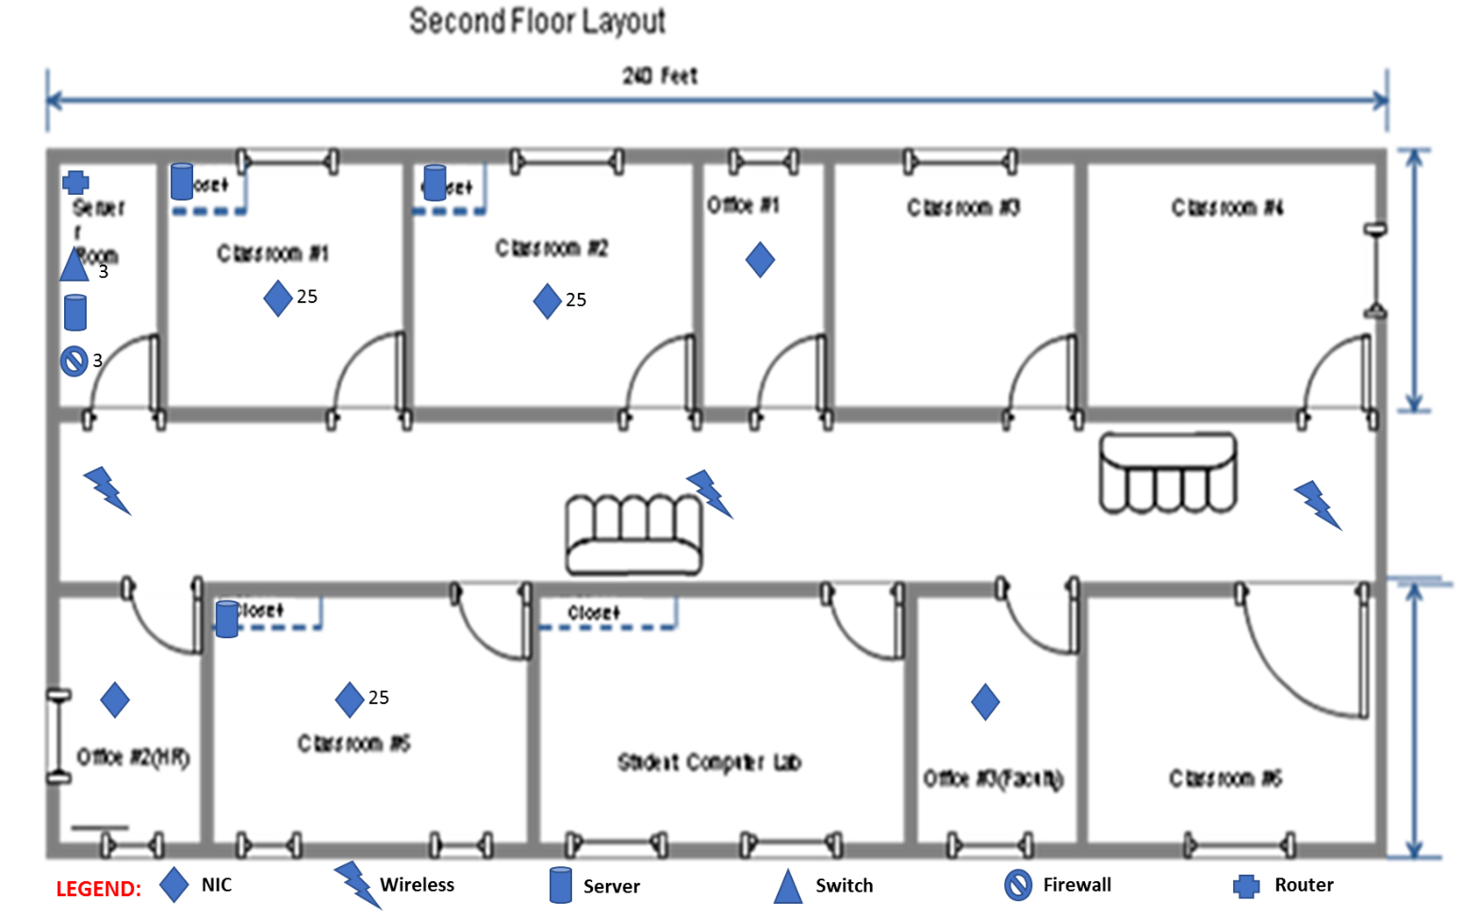
Figure 3. Diagram and equipment location

Justification

The proposed network connections cover all the required building needs. Using a combination of wired and wireless technology. Users will also be able to access the 802.11 b/g/n 2.4 GHz and 802.11 a/n/ac high speed network easily from any space of the building. The staff will be able to share files, hardware, services, and information. Students will have access to UMUC’s website LEO and to the internet for access to resources.

D. Network Security Devices

Business Needs

Security need on a network is at an all-time high. Hackers are getting bolder every day. UMUC has to protect its students, faculty and its resources. With social media being part of majority of society daily living, vulnerabilities are extremely high. According to one security institution, 15% of all recorded security breaches have occurred at an educational facility. The number of incidents are on the rise as well. 2012 had the highest number of cases of compromised records in higher education since 2006. With these incidents on the rise and attackers more willing than ever to go after schools, the importance of network security for education cannot be overstated [4].

Proposed Network Security Devices

I chose to go with CISCO ASA 5505 Firewall in which DMZ (Demilitarized Zone) can be configured. You can look at what NAT (Network Address Translation) and ACL (Access Control Lists) configuration will be needed in order to allow inbound access to a web server in the DMZ of an ASA firewall, and allow outbound connectivity from internal and DMZ hosts.

Justification
The CISCO ASA 5505 was select because of the layers of protection that it provides. It will ensure the staff, students and resources are protected

E. Computer Systems

Business Needs

UMUC must manage data, file sharing as well as backing up sensitive information. To perform administrative tasking and allow instructors/students to conduct academic activity; workstations and servers must be adequate.

Proposed Computer Systems

The selected servers are the Dell PowerEdge R710 2U for the server rooms and the Dell PowerEdge T20 Mini-tower Server System Intel Xeon for the classroom closets. Each server will have Windows Server 2016 installed. The two in the server rooms, one server will run the Microsoft Exchange and the other will serve as the file server.

Justification

I selected the Windows Server 2016 for my servers because of the latest features of the OS.
- Windows Server Container. This container type is intended for low-trust workloads where you don't mind that container instances running on the same server may share some common resources
- Hyper-V Container. This isn't a Hyper-V host or VM. Instead, its a "super isolated" containerized Windows Server instance that is completely isolated from other containers and potentially from the host server. Hyper-V containers are appropriate for high-trust workloads [5].
Storage Spaces Direct in Windows Server 2016 extends Storage Spaces to allow failover cluster nodes to use their local storage inside this cluster, avoiding the previous necessity of a shared storage fabric [5].

Bibliography

[1] E. Jeetander, “Star Topologies and Its Advantages and Disadvantages” http://top10electrical.blogspot.com/2016/05/star-topologies-and-its-advantages-and.html [Accessed: 28-Feb-2017]

[2] G. Hamel, “Advantages for Using the Internet in University Education” http://www.businessinsider.com/internet-of-things-education-2016-9 [Accessed: 28-Feb-2017]

[3] A. Britnor, “Keep Up! – Adapting to an Ever-changing Business and Technology World” Linked in, 22-Jan-2016. [online]. https://www.linkedin.com/pulse/keep-up-adapting-ever-changing-business-technology-britnor-guest [Accessed: 28-Feb-2017]

[4] R. Delgado, “The Importance of Network Security in Schools” Social Media Today, 31-Aug-2014. [online]. http://www.socialmediatoday.com/content/importance-network-security-schools [Accessed: 01-Mar-2017]

[5] T. Warner “10 Best New Features in Windows Server 2016” Tom’s It Pro, 14-Oct-2016. [online]. http://www.tomsitpro.com/articles/best-windows-server-2016-features,2-1061.html [Accessed: 01-Mar-2017]

